

LINE INTERACTIVE UPS


AD SERIES

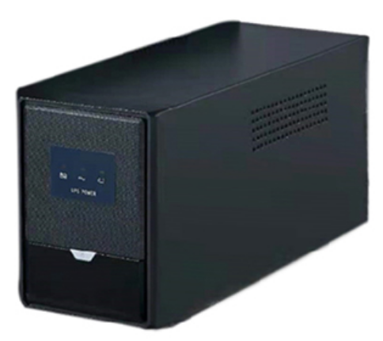
- SMT Technology, Line Interactive UPS
- Metal Case with (On-Off Control)
- Built-in Boost and Buck AVR (Automatic Voltage Regulator)
- With surge protection
- Protection for Short Circuit, overload and battery low voltage
- LED indication and audible alarm function
- Silence Setup and Smart battery management function
- AUTO Restart function when AC recovers
- Off charge and Cold Start function
- RJ45 and USB is option
- LED Display
UPS 1200VA
UPS1000VA

Item | Model | AD1200
Capacity | VA/ Watts | 1200VA/720W
Input | Voltage Range | 220VAC/230VAC/240VAC
Input | Nominal Voltage | 220VAC
Input | Frequency | 50Hz-60Hz
Output | Voltage Range | 220VAC/230VAC/240VAC
Output | Nominal Voltage | 220VAC
Output | Frequency | 50Hz-60Hz
Output | Transfer Time | ≤10 ms including direction time
Output | Waveform | Modified Sine wave (Battery Mode)
Output | Power Factor | 0.60
Output | Connections | 3-4 universal output sockets
Battery | Type | Sealed lead acid maintenance-free, auto inspection, discharge protection and battery fault caution
Battery | Capacity | 12V, 9Ah
Battery | Charging time | 6 Hours
Protection | Full Protection | Over discharge, short circuit and overload protection
Alarm | Battery Mode | Sounding every 4 seconds
Alarm | Low Battery | Sounding every second

Exclusive Distributor:
AUTOMATION SPECIALISTS AND POWER EXPONENTS, INC.
ASPEX Bldg., 159 Boni Avenue, Brgy. Plainview, Mandaluyong City
Email: aspex@aspexinc.com.ph
Trunk line: (02) 8997-0000 Fax: (02) 8532-7228

