

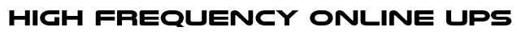
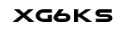

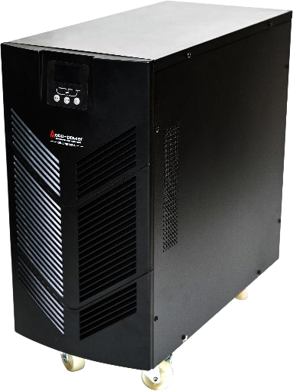
- LCD High Frequency Online Double Conversion UPS
- DSP digital control technology, Zero transfer time
- Single Phase Sine Wave, Output Power Factor 0.9 adjustable VAC and Hz by panel
- Wide Input Voltage and Frequency Range, Support Generator
- Self-testing and battery management function
- Automatic battery charging while UPS off mode
- Lightning, Surge, Short Circuit and Overload Protection, Alarm or Silence Settable
- Automatic and Manual Bypass

Item | Model | XG6KS
Capacity | VA / Watts | 6KVA / 5.4KW
Input | Rated voltage | 220/230VAC, Single Phase
Input | Voltage range | within +/-20% of rated voltage
Input | Frequency | 60Hz
Output | Normal voltage | 220/230VAC, Single Phase
Output | Voltage regulation | ±1%
Output | Frequency | 60Hz ± 0.5%
Output | Wave form | Pure Sine Wave
Output | Transfer time | 0 ms
Output | Power factor | 0.8
Output | Crest factor | 3:1
Output | Overload | 125% - 150% for 30secs.
Battery | Battery Type | Maintenance free valve regulated lead acid (VRLA) battery
Battery | Configuration | External
Battery | Battery Cabinet | C4, w/ Battery Circuit Breaker
Battery | Back-up time | 15 minutes @ Full Load
Battery | Recharge time | ≤5 Hours to 90% capacity
Display | LCD Panel | Input/ Output Voltage
Display | LCD Panel | Frequency
Display | LCD Panel | Load (KVA/Watts and Percentage)
Display | LCD Panel | Battery Level
Display | LCD Panel | Operating Mode and Alarms
Working  Environment | Working Temperature | - 20℃～40℃
Working  Environment | Humidity | 0-95% non-condensing
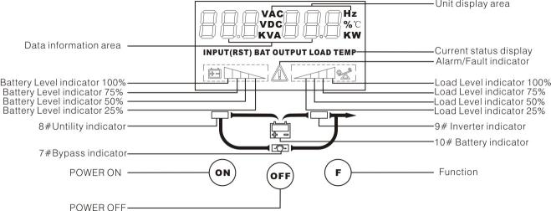


Exclusive Distributor
AUTOMATION SPECIALISTS AND POWER EXPONENTS, INC.
ASPEX Bldg., 159 Boni Avenue, Brgy. Plainview, Mandaluyong City
Trunk line: (02) 8997-0000 Fax: (02) 8532-7228
www.aspexinc.com.ph

